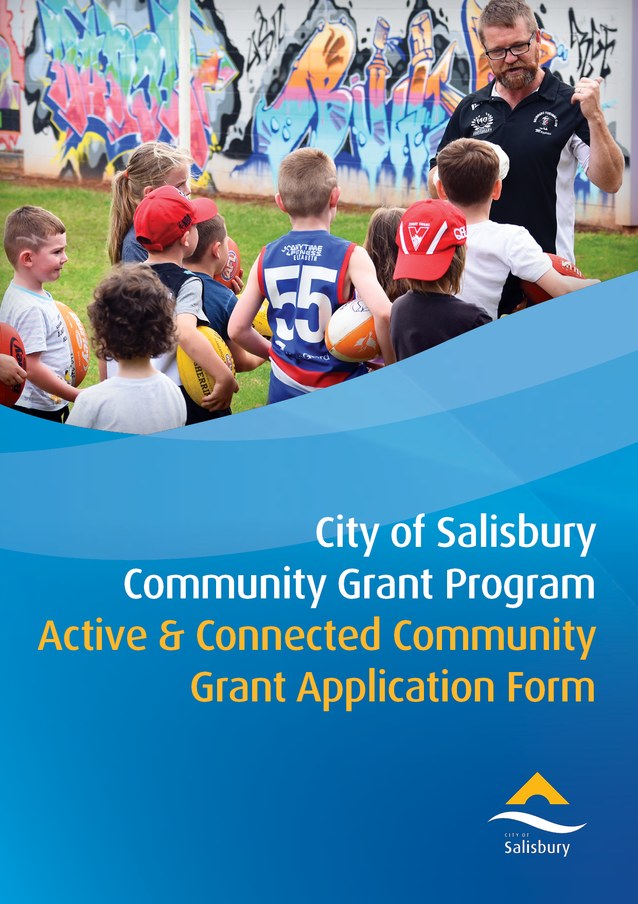

Please ensure you have read and understood the City of Salisbury Community Grants
Program Guidelines and Eligibility Criteria document prior to completing an application.
Part 1 - Applicant Information
CONTACT DETAILS
Name:
Title (your role with the group/organisation):
Address:
Phone:
Email:
GROUP / ORGANISATION / BUSINESS / SCHOOL / INSTITUTION DETAILS
Name:
Registered Address:
Suburb: | Postcode:
Phone:
Website:
GROUP / ORGANISATION / BUSINESS / MANAGEMENT DETAILS
ABN:
Registered for GST: | ☐ Yes ☐ No
Not For Profit Deductible Gift Recipient (DGR) status by the Australian Taxation Office: | ☐ Yes ☐ No
Have you or your organisation previously received funding from the City of Salisbury? | ☐ Yes ☐ No  Please advise when, amount granted and what it was for:
5. BANKING INFORMATION
Account Name:
BSB:
Account Number:
Program Priorities
What program priorities does your application best align to?  (please tick which is applicable) | ☐ Create opportunities for people to connect with each other  ☐ Celebration of diverse community and collaborations  ☐ Deliver inclusive responses to meet the needs of isolated and marginalised groups  ☐ Develop and strengthen Reconciliation* practices  ☐ Encourage residents and community groups to actively participate in their local city community and neighbourhood  ☐ Increase physical activity in our community  ☐ Decrease social isolation and reduce loneliness in our community  ☐ Empower the community’s means of self-development and achievements  *Reconciliation is about strengthening relationships between Aboriginal and Torres Strait Islander peoples and non-Indigenous peoples, for the benefit of all Australians.

Part 2 - Application Summary
What is the funding for?(please tick which is applicable) |  | - Youth Sponsorship  - Defibrillator  - Sporting Equipment  - Small to medium Event  - Program  - New Community Group  - Neighbourhood Activation  ☐ Other: please describe
Name of the Application
Proposed date(s)  (commencement to completion) |  | From to
Location of activity/event
(Activities and Events must occur within the City of Salisbury)
Provide a brief description of the proposed activity/event  (Please refer to supporting documents including quotes and list them in Part 5) |  | (max 100 words)
Describe how the activity/event will align with the program priorities as outlined on previous page. |  | (max 100 words)
Which grant size are you applying for? |  | - Mini Grants are to the value of $2,000 (incl. GST) - Fill in funding details below  - Small Grants are from $2,000 and to the value of $7,000 (incl. GST) - Go to Part 3  - Medium Grants are from $7,000 and to the value of $12,000 (incl. GST) - Go to Part 3
Mini Grants - Amount of Funding Requested and for what purpose  (e.g. equipment, Welcome to Country, performers fees, hall hire, sporting competition fees) |  | Funding requested $  Total activity/event budget $  Purpose of funding:
If successful, please describe how the support from the City of Salisbury will be acknowledged. | (max 100 words)
NEXT STEPS:
☐ Youth Sponsorship - please download and complete the Declaration form and attach it with this application and send to communitygrants@salisbury.sa.gov.au for consideration
☐ MINI GRANTS (Up to $2k) - please sign the declaration page in Part 7 of this application, save a copy in your personal files and send to communitygrants@salisbury.sa.gov.au for consideration with relevant supporting documents listed in Part 5
☐ For any applications requesting more than $2k, please continue

Part 3 - Small to Medium Grants ONLY ($2k - $12k)
Please describe how your proposal demonstrates a clear alignment with and outcomes based on Council’s City Plan. | (max 200 words)
Please describe the community benefit of your activity/event.  (e.g. participation numbers, % of City of Salisbury residents, expected outcomes, community needs, future legacy) | (max 200 words)
Please outline the impact your activity/event seeks to achieve including how it will be evaluated. | (max 200 words)
Please describe or list key partners and/or stakeholders, community members and organisations that have been consulted, how and why they support the activity/event and any other information that demonstrates support  If you have letters of support please attach them to your application as evidence. | (max 150 words)
How will the activity/event be promoted?  If successful, applicants will be required to acknowledge and promote the City of Salisbury’s contributions. | (max 200 words)
Please summarise the major risks and mitigation strategies associated with this activity/event.  Note: this does not replace the need to conduct a full risk assessment process | (max 200 words)
Part 4 - Medium Grants ONLY ($7k - $12k)
Apart from your organisation, please provide details of how this activity/event will positively impact any other local groups or businesses.  (e.g. Local Business, Members, Volunteers, Staff, Customers, Community Organisations) | (max 200 words)
Please describe how your activity/event is accessible and inclusive for the community.  (e.g. no cost, ASL interpreters, wheelchair access, quiet areas) | (max 150 words)
How will you deliver a sustainable activity/event?  Please review the State Government’s Waste and Recycling at Events and Venues Guideline for suggestions. | (max 150 words)

Part 5 – Supporting Documentation
Please list and attach any relevant and supporting documentation including but not limited to:
- Quotes
- Event Plan/Checklist
- Risk Management Plan
- Traffic Management Plan
- Venue permit/Hire Agreement
- Project Plan/Timeline
- Letters of Support

Part 6 - Budget Breakdown
Amount Requested | $
Total Budget | $
Itemised Breakdown of Costs:
An itemised breakdown of costs must be provided. Please attach a separate sheet if there is insufficient space.
 | $
 | $
 | $
 | $
 | $
 | $
 | $
 | $
 | $
 | $
 | $
 | $
 | $
 | $
 | $
TOTAL (including GST): | $
Quote Attached:  A detailed, current quote must be provided with the application. | - Yes | - No

Application Declaration
Part 7 - APPLICATION DECLARATION
This declaration must be completed by an authorised representative of the applicant (or, if this application is a joint/consortium application, authorised representative of the lead organisation).

The authorised representative should be a person who is legally empowered to enter contracts and commitments on behalf of the applicant.

For groups or organisations, 2 signatories from senior office holders will be required.

Please read, tick the boxes and sign below

- I/We acknowledge that I am authorised to make this application on behalf of the Organisation.
- I/We acknowledge that the information provided in this application is true and correct.
- I/We acknowledge that application needs to be acquitted within 6 months of receipt of funds as set out in the Acceptance of Community Grant – Form 1 and City of Salisbury Community Grants Program Guidelines and Eligibility Criteria as set out
- I/We acknowledge that our Organisation may be required to supply further information prior to consideration of this application by the City of Salisbury Community Grants Program.
- I/We acknowledge that any changes in circumstances regarding this Application must be notified in writing, and the City of Salisbury Community Grants Program may request more information.

On behalf of (Group/Organisation)

(Name) (Name)

(Position) (Position)

(Signature 1) (Signature 2)

(Date) (Date)

