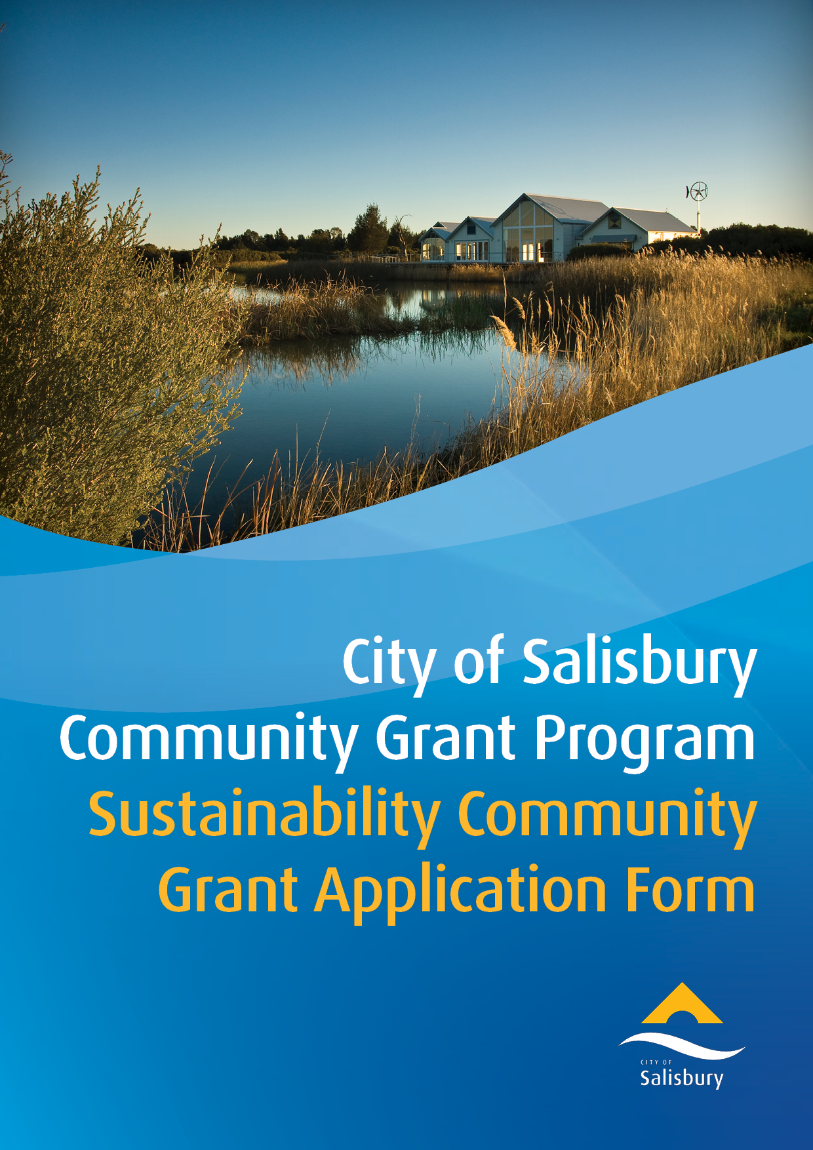

|  |  |
| --- | --- |
| **Please ensure you have read and understood the City of Salisbury Community Grants** [**Program Guidelines and Eligibility Criteria document**](https://www.salisbury.sa.gov.au/assets/downloads/Sustainability-Community-Grant-Guidelines.pdf) **prior to completing an application.** | |
| **Part 1 - Applicant Information** | |
| ***CONTACT DETAILS*** | |
| Name: |  |
| Title (your role with the group/organisation): |  |
| Address: |  |
| Phone: |  |
| Email: |  |
| ***GROUP / ORGANISATION / BUSINESS / SCHOOL / INSTITUTION DETAILS*** | |
| Name: |  |
| Registered Address: |  |
| Suburb: | Postcode: |
| Phone: |  |
| Website: |  |
| ***GROUP / ORGANISATION / BUSINESS / MANAGEMENT DETAILS*** | |
| ABN: |  |
| Registered for GST: | Yes  No |
| Not For Profit Deductible Gift Recipient (DGR) status by the Australian Taxation Office: | Yes  No |
| Have you or your organisation previously received funding from the City of Salisbury? | Yes  No  Please advise when, amount granted and what it was for: |
| ***BANKING INFORMATION*** | |
| Account Name: |  |
| BSB: |  |
| Account Number: |  |
| **Program Priorities** | |
| **What program priorities will your application best align to?**  ***(please tick which is applicable)*** | **Greenhouse Gas Emissions Reduction**  Completion of energy efficiency audits to identify priority initiatives.  Installation of appliances or equipment that reduces the energy use and greenhouse gas emissions of the organisation.  Development of greenhouse gas inventories and emissions reduction strategies.  **Climate Resilience**  Installation of rainwater tanks or Water Sensitive Urban Design (WSUD) interventions (e.g. permeable paving, rain gardens, tree inlets).  **Resource Recovery and Circular Economy**  Completion of waste minimisation audits to identify priority actions.  Installation of resource recovery systems including food and garden organics separation, co-mingled recyclable.  Trialling or purchase of commercial rapid composters, commercial dehydrators or similar systems to divert green waste from landfill.  Signage and education materials.  Other initiatives that assist to avoid and reduce waste including achievement of circular economy outcomes. |

|  |  |
| --- | --- |
| **Part 2 - Application Summary** | |
| **What is the funding for?**  ***(please tick which is applicable)*** | Energy efficiency audit to identify priority initiatives.  Solar photovoltaic systems.  Energy battery storage systems connected to a solar photovoltaic system.  Replacement of gas appliances with energy efficient electric or solar powered (eg hot water, heating, cook tops or ovens).  Energy efficiency upgrades recommended in an energy efficiency audit.  Greenhouse gas inventory developed by a qualified consultant.  Greenhouse gas emissions reduction strategies developed by a qualified consultant.  Rainwater tanks and plumbing of the tank to an appliance, fixture or irrigation.  Water Sensitive Urban Design (WSUD) interventions (eg permeable paving).  Completion of waste minimisation audits to identify priority actions.  Other: please describe: |
| **Name of the Application** |  |
| **Proposed date(s)**  (Commencement to completion) | From to |
| **Location of activity**  **(**Activities must occur [within the City of Salisbury](https://www.salisbury.sa.gov.au/council/elected-members-and-wards#ward-map)) |  |
| **Are you the property owner or tenant?**  (Note that some activities such as installation of solar photovoltaic panels will require property owner consent) | Property Owner  Tenant |
| **Does your activity require development approval?**  If development approval is required you must obtain approval prior to grant monies being provided.  Please review [Frequently Asked Questions](https://www.salisbury.sa.gov.au/council/grants-and-awards/grants/community-grants-2/community-grants-2) to check if development approval is required for your project. | Yes  No  Don’t know |
| **Provide a brief description of the proposed activity**  (Please refer to supporting documents including preferred quote etc. as listed in Part 4) | *(max 100 words)* |
| **Describe how the activity will align with the program priorities as outlined on previous page** | *(max 100 words)* |
| **Which grant size are you applying for?** | Mini Grants are to the value of $2,000 (incl. GST) - Fill in funding details below  Small Grants are from $2,000 and to the value of $7,000 (incl. GST) - Go to Part 3 |
| **Mini Grants - Amount of Funding Requested and for what purpose**  (e.g. the purpose could include equipment purchase, energy audit, signage etc.) | Funding requested $  Total activity budget $  Purpose of funding: |
| **If successful, please describe how the support from the City of Salisbury will be acknowledged**. | *(max 100 words)* |
| **NEXT STEPS:** | |
| **MINI GRANTS (UP TO $2K) -** please sign the declaration page in Part 6 of this application, save a copy in your personal files and send to communitygrants@salisbury.sa.gov.au for consideration with relevant supporting documents listed in Part 4.  **FOR ANY SMALL GRANT APPLICATIONS REQUESTING MORE THAN $2K, PLEASE CONTINUE** | |

|  |  |
| --- | --- |
| **Part 3 – Further Information - Small Grants ONLY ($2k - $7k)** | |
| **Environmental sustainability improvements**  **What are the expected environmental sustainability improvements to the operations of your organisation due to the proposed activity?**  (e.g. amount of solar power to be generated, amount of energy use reduction, reduction in greenhouse gas emissions, quantity of waste to be diverted from landfill) | (max 200 words) |
| **Operating Costs**  **Do you expect the proposed activity to reduce your operating costs and by how much?** | (max 100 words) |
| **Suppliers**  **To complete the proposed activity, approximately what percentage of purchases by cost will be local City of Salisbury, Adelaide or South Australian suppliers and products?** | City of Salisbury based: ………….. %  Adelaide based: ………….. %  South Australian based: ………….. % |

|  |
| --- |
| **Part 4 – Supporting Documentation – Mini and Small Grants** |
| **Please list and attach any relevant and supporting documentation including but not limited to:**   * Preferred quote for new appliances/equipment/development of greenhouse gas inventory/energy audit * Photos of appliance/equipment to be replaced * Design of water sensitive intervention or other proposed installations * Property owner consent |
|  |
|  |
|  |
|  |
|  |
|  |
|  |
|  |
|  |
|  |

|  |  |  |
| --- | --- | --- |
| **Part 5 - Budget Breakdown – Small Grants ONLY** | | |
| **Amount Requested** | $ | |
| **Total Budget** | $ | |
| **Itemised Breakdown of Costs:**  ***An itemised breakdown of costs must be provided. Please attach a separate sheet if there is insufficient space.*** | | |
|  | $ | |
|  | $ | |
|  | $ | |
|  | $ | |
|  | $ | |
|  | $ | |
|  | $ | |
|  | $ | |
|  | $ | |
|  | $ | |
| **TOTAL (including GST):** | **$** | |
| **Quote Attached:**  ***A detailed, current quote must be provided with the application.*** | Yes | No |

|  |
| --- |
| **Part 6 - Application Declaration – Mini and Small Grants** |
| This declaration must be completed by an authorised representative of the applicant (or, if this application is a joint/consortium application, authorised representative of the lead organisation).  The authorised representative should be a person who is legally empowered to enter contracts and commitments on behalf of the applicant.  For groups or organisations, 2 signatories from senior office holders will be required.  *Please read, tick the boxes and sign below*  I/We acknowledge that I am authorised to make this application on behalf of the Organisation.  I/We acknowledge that the information provided in this application is true and correct.  I/We acknowledge that application needs to be acquitted within 6 months of receipt of funds as set out in the Acceptance of Community Grant – Form 1 and City of Salisbury Community Grants Program Guidelines and Eligibility Criteria as set out  I/We acknowledge that our Organisation may be required to supply further information prior to consideration of this application by the City of Salisbury Community Grants Program.  I/We acknowledge that any changes in circumstances regarding this Application must be notified in writing, and the City of Salisbury Community Grants Program may request more information.  On behalf of *(Group/Organisation)*    ***(Name)******(Name)***  ***(Position) (Position)***  ***(Signature 1) (Signature 2)***  ***(Date) (Date)*** |